**Functional Specification**

**Draft Version: 00**

Author: Rameshbabu Peddapalli

Date: 18 September 2016

* It shall be possible to store the patient information in database permanently using save button [ref 1].
* It shall be possible to retrieve the patient information from database whenever required using load button [ref 1]
* The dialog has to be displayed as mentioned in the **Figure 1**
* It shall be possible to minimize the patient explorer dialog by clicking on **–** button which is displayed on the top right corner
* It shall be possible to close the patient explorer dialog by clicking on **X** button which is displayed on the top right corner

**UID:**

1. Each patient is assigned with unique id
2. UID shall contain only numbers
   1. If user enters other than expected display error message saying “UID accepts only numbers”
3. The maximum number of digits allowed is 9999999999
   1. If user enters other than expected display error message saying “UID can’t be more than 9999999999”
4. UID shall not contain 0
   1. If user enters other than expected display error message saying “UID can’t be zero”
5. UID shall not contain negative values
   1. If user enters other than expected display error message saying “UID doesn’t accept negative numbers”

**Name:**

1. Name shall not contain special characters
2. Name shall not contain numbers
3. Length of the name shall not more than 50 characters

**DOB:**

1. Date of birth format shall be in dd/mm/yyyy
2. Date of birth shall not be less than 1866
3. Date of birth shall not be greater than today
4. Date of birth

**Age:**

1. Age shall accept only numbers
2. Age shall not be given in months
3. Age shall not be more than 150
4. Age shall not accept negative numbers

**Sex:**

1. Sex shall accept only either one of the following Male or Female or Other

**Height:**

1. Height shall accept only in following format Feet’ Inches
2. Feet shall be between 0 and 9
3. Inches shall be between 0 and 12

**Weight:**

1. Weight shall accept only numbers
2. Weight shall not accept negative numbers
3. Weight shall not accept more than 300kgs

**Birthday:**

1. Birthday shall be calculated based on the provided date

**Address:**

1. Address shall be accepted characters, numbers and any of the following characters like #, ., @

2. Address should not accept only numbers

**Aadhaar No:**

1. Aadhaar number shall accept only numbers

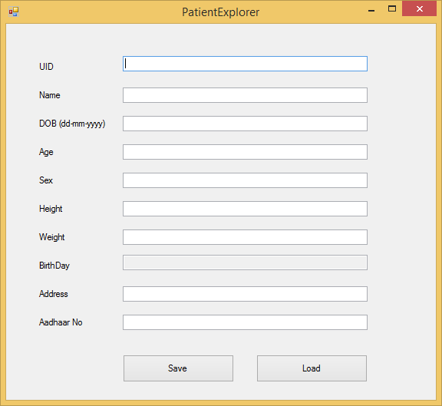

Figure 1